BSc (Hons) Computing Course 2025/26
Level 6 Production Project
Name: Deepak Subedi | Student I.D.:  77466899
Course: BSc (Hons) Computing | Supervisor’s Name:
Final Project Individual Aim & Objectives
Title of my Project:
Smart Medication Reminder with Pill Recognition
Aim of my Project:
The aim of this project is to design and develop a mobile application that helps users take medication on time and verifies the medicine using pill recognition through computer vision.
Objectives of my Project:

∙ Study existing mobile health (mHealth) applications and reminder systems.
∙ Research computer vision techniques for pill recognition.
∙ Collect a small pill image dataset for training.
∙ Design and implement a mobile reminder system.
∙ Train a machine learning model to identify pills.
∙ Convert the model to mobile-friendly format (e.g., TensorFlow Lite).
∙ Integrate pill recognition into the mobile app.
∙ Log medication history (taken/missed).
∙ Test system accuracy and performance (e.g. response time, reliability).
∙ Evaluate results and document limitations.

Specification of my Product:

The product specification is divided into functional and non‑functional requirements, which are prioritised using the MoSCoW method as shown below:
Functional Requirements MoSCoW
Users can create, edit and delete medication schedules (name, dose, time, duration). | M
The system sends reminder notifications at the scheduled medication time. | M
Users can confirm taking medication through the app (mark as taken / missed). | M
Application allows users to capture pill images using the mobile camera. | M
Application runs pill recognition on the captured image using a TensorFlow Lite model. | M
Application checks whether the recognized pill matches the scheduled medication. | M
Application stores medication history (taken, missed, time, date) in a local database. | M
Application displays basic feedback (e.g. Correct pill, Wrong pill,Uncertain). | M
Application provides a simple daily/weekly view of the medication schedule. | S
Application allows the user to view past medication history. | S
Application supports a basic user profile (e.g. name, simple settings). | S
Application shows simple statistics (e.g. missed vs taken doses). | C
Application can handle multiple different pills per time slot. | C
Application integrates with external services | W
Application supports multi‑language user interface. | W

Non-Functional Requirements MoSCoW
Developed by using free / open‑source software (Flutter, TensorFlow, etc.). | M
Product is evaluated and verefied with sample data and predefined test scenarios. | M
Product displays a clear medical disclaimer (not a replacement for a doctor). | M
User data is stored securely on the device. | M
The product is user friendly and easy to navigate. | S
Codebase is platform independent (Flutter) and runs on iOS, with potential for Android. | W
Pill recognition returns results within a reasonable time | S
Pill recognition model maintains acceptable accuracy (e.g. ≥ 80% on test data). | S
Core features reminders, local history work offline. | S

Research:
The average level of adherence to long-term treatments is estimated to be around 50% (World Health Organization, 2003; Nieuwlaat et al., 2014). Nonadherence to prescribed medications has been cited as a leading contributor to preventable illness and increased healthcare costs. Medication reminders via smartphone apps have shown promise in addressing this issue as evidence from secondary research demonstrating the effectiveness of properly designed mobile applications to significantly improve adherence in patients suffering from chronic conditions when these mobile applications are capable of sending reminder notifications, tracking medication dosages, providing patient feedback, etc(Nieuwlaat et al., 2014). However, it is worth noting that many mobile applications currently available only offer reminder notifications without an established method for confirming whether the patient has taken the correct medication(s) (Tabi, Randhawa and Choi, 2019.). On the other hand, an increase in technological advancements in the development of computer vision and deep learning technologies have enabled the recognition of medications based on photographs. For example, the use of CNNs achieved high rates of accurate classification for large datasets of prescription medications and would be adequately deployable within a mobile environment using existing software development platforms (e.g., TensorFlow Lite) (Nguyen Thi My et al., 2025). This combination of technological advances and evidence-based practices makes a smart reminder app incorporating pill recognition into a viable direction for this project.
Evaluation:
As specified in the product requirements and objectives, the final system will be evaluated on how well it supports medication adherence and correctly recognises pills. Quantitative evaluation will focus on testing the pill recognition model on a held‑out dataset to measure accuracy and related metrics, as well as recording the time taken to produce a result on the mobile device. The reminder and logging features will also be checked to ensure that notifications trigger at the correct times and that taken/missed doses are stored accurately.A number of realistic tests will also be developed that will involve a variety of pill pictures, lighting conditions and schedules of all various types of medications to determine if the system works in a repeatable way. The success of the entire project will be determined by its technical results and by how well the implemented features fit within the specifications and requirements.

Project Planning:
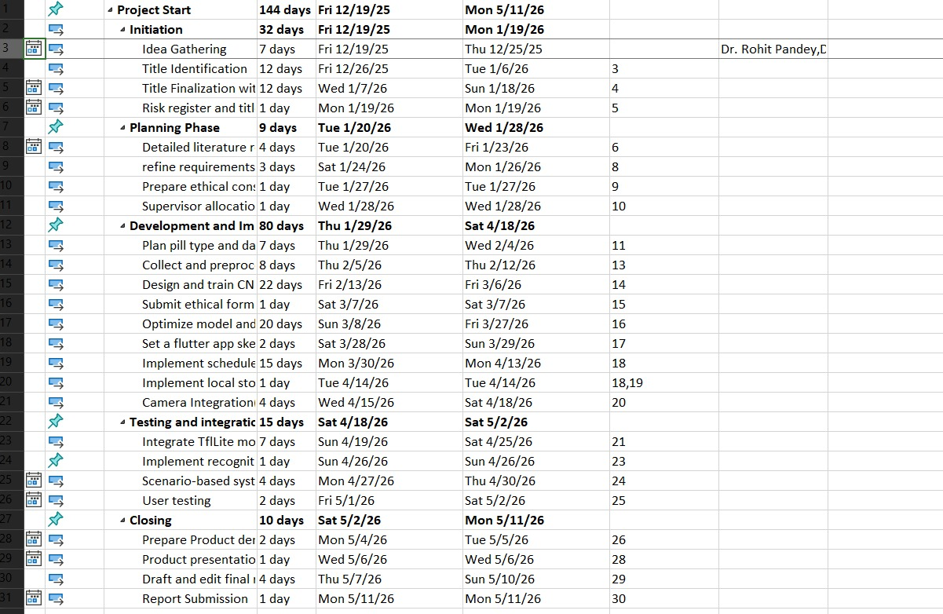

Fig: Project planning Task Sheet

Gantt Chart
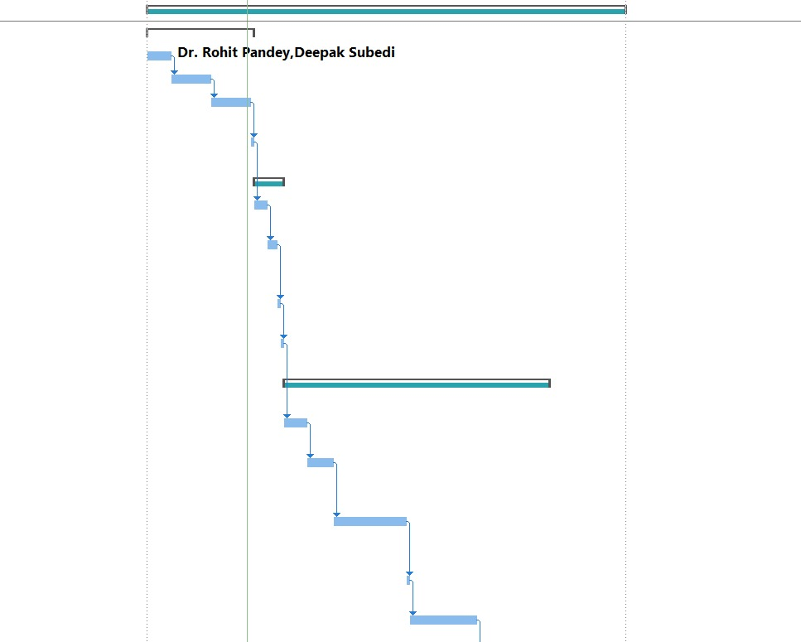
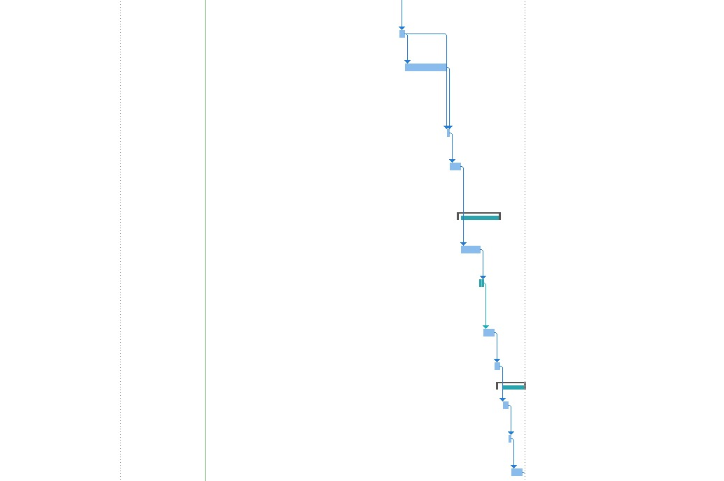

Fig: Gantt Chart Illustrating Project Planning

Timeline
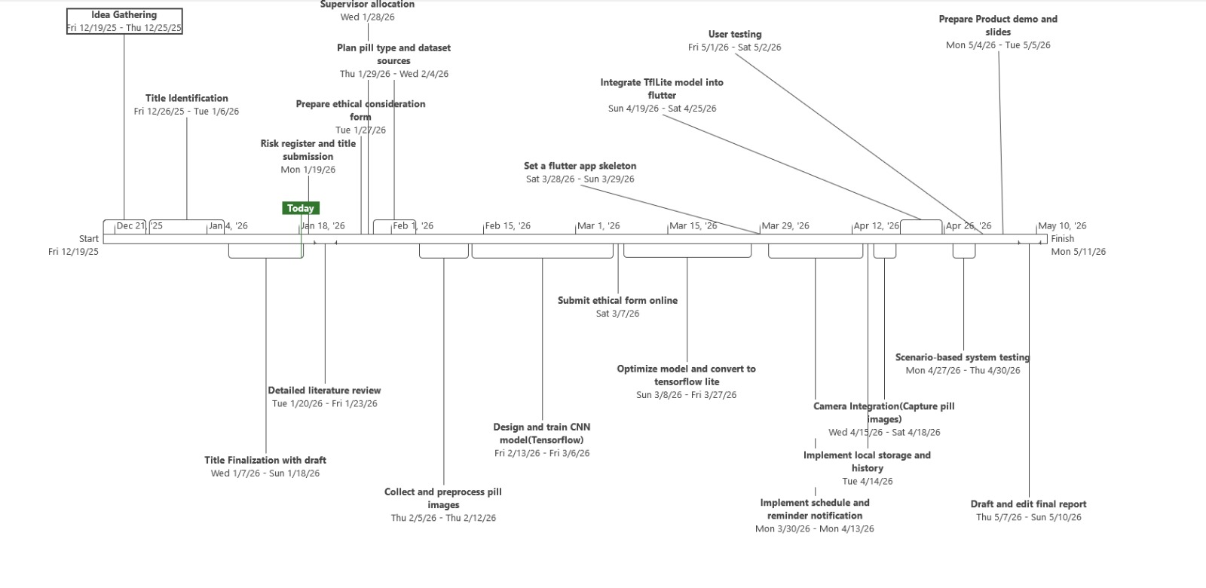
Fig: Project Timeline
Methodology:
This project uses a mixed research and Agile methodology that is directly shaped by the literature. Evidence on poor medication adherence and the value of reminder‑based tools (World Health Organization, 2003; Nieuwlaat et al., 2014; Tabi, Randhawa and Choi, 2019) guided the decision to build a simple, schedule‑driven mobile app with clear logging of taken and missed doses. Work on pill image recognition using deep learning (Nguyen Thi My et al., 2025)showed that convolutional neural networks can reliably identify pills from images and can be deployed on mobile devices, which inspired the use of TensorFlow and TensorFlow Lite for the recognition component. Following incremental development principles (Pressman and Maxim, 2020) and the TensorFlow Lite workflow (TensorFlow, 2024), I will first prepare a small pill image dataset and train a CNN in Python on my MacBook Air, then convert the selected model to TensorFlow Lite and integrate it into a Flutter app. The app will be developed in short iterations starting with basic scheduling and reminders, then adding storage, camera capture and finally pill recognition with each step tested against predefined scenarios to confirm that the system behaves as intended.

Resources:
The list of resources (hardware and software) is given below. All the main software tools are free or open source and can be installed on the MacBook Air.
Item | Source
macOS Tahoe 2.6 | Own
Flutter SDK | Own
Dart SDK | Own
Xcode | Own
Android Studio or VS Code with Flutter extensions | Own
Python 3.x | Own
TensorFlow and TensorFlow Lite | Own
Jupyter Notebook or similar environment for experiments | Own
SQLite / sqflite package for local database | Own
flutter_local_notifications package for reminders | Own
Git and GitHub for version control | Own
Microsoft Word and PowerPoint for documentation and presentation | Own
Web browsers: Google Chrome, Safari | Own

The hardware I require to complete my Project successfully:

Item | Source
MackBook Air Laptop | Own
Phone | Own

Human Resource

Name | Role
 | Supervisor
Deepak Subedi | Researcher/Programmer

I am working on my Project with the following people
Name: | Role:  Module Leader  Supervisor
Bibliography
1.Nguyen Thi My, L., Le, V.-T., Vo, T. & Hoang, V. T. (2025) A Comprehensive Review of Pill Image Recognition [online]. Computers, Materials & Continua, 82(3), pp. 3693–3740. Available at: https://www.techscience.com/cmc/v82n3/59929/html

2.Nieuwlaat, R., Wilczynski, N., Navarro, T., et al. (2014) ‘Interventions for enhancing medication adherence’, Cochrane Database of Systematic Reviews, 11, CD000011.
Available at: https://www.cochranelibrary.com/cdsr/doi/10.1002/14651858.CD000011.pub4/full

3.Tabi, K., Randhawa, A.S. and Choi, F. (2019) ‘Mobile apps for medication management: A review of the apps in the Google Play Store’, Healthcare Informatics Research, 25(1), pp. 12–19.
Available at:https://pubmed.ncbi.nlm.nih.gov/31512580/

4.World Health Organization (2003) Adherence to long-term therapies: Evidence for action. Geneva: World Health Organization.
Available at: https://iris.who.int/items/bf8058c0-03b2-4b47-838f-5534849927fb

5.TensorFlow (2024) TensorFlow Lite guide. Available at: https://www.tensorflow.org/lite (Accessed 10 January 2026).
Available at:https://www.tensorflow.org/lite

Risk Register

ID | Risk Description | Likelihood | Impact | Severity | Owner | Mitigation | Status
1 | Not collecting enough suitable pill images (or poor‑quality images) to train a reliable model | Medium | High | High | Deepak Subedi | Start image collection early; restrict scope to a small number of pill types; use consistent lighting and backgrounds; apply data augmentation (rotation, brightness) to increase dataset size | open
2 | Trained pill recognition model does not reach acceptable accuracy (e.g. ≥ 80% on test data). | Medium | High | High | Deepak Subedi | Begin with a simple CNN baseline and iterate; use transfer learning from a pre‑trained model if needed; reduce number of pill classes; clearly document actual accuracy and limitations in the report. | open
3 | TensorFlow Lite model runs too slowly on the phone, causing long delays after image capture. | Medium | Medium | Medium | Deepak Subedi | Test inference speed early on the real device; use model optimisation (quantisation, smaller input size); simplify architecture if required; ensure inference runs off the main UI thread. | open
4 | Technical issues integrating TensorFlow Lite with Flutter (incompatible plugins, build errors). | Medium | Medium | Medium | Deepak Subedi | Use well‑maintained Flutter/TFLite packages; follow official examples; first build a small test app that only loads and runs the model; keep Flutter and plugins at compatible versions; allow extra time for | open
5 | Problems with iOS build, provisioning or device deployment (Xcode, signing, certificates). | Medium | Medium | Medium | Deepak Subedi | Set up Xcode, developer account and device provisioning early; follow Flutter and Apple documentation; regularly build and run on the test phone. | open
6 | Time overrun due to underestimating effort (model + app + evaluation + report). | Medium | High | High | Deepak Subedi | Follow the project Gantt chart; prioritise Must‑have features (schedules, reminders, basic recognition) before Should/Could; set internal mini‑deadlines each week; reduce non‑essential features if delays occur. | open
7 | Loss or corruption of code, datasets or report files (e.g. laptop failure, accidental deletion). | Low | High | Medium | Deepak Subedi | Use Git and GitHub for version control with frequent commits; back up datasets and report drafts to cloud storage (e.g. OneDrive/Google Drive); avoid keeping the only copy of work on one device. | open
8 | Ethical / safety risk: users treat the prototype as a medical device or rely on it instead of a doctor. | Medium | Medium | Medium | Deepak Subedi | Clearly label the app as a student project / prototype; include a visible disclaimer screen stating it does not replace professional medical advice; avoid real patient data and do not promote clinical use. | open
9 | Scope creep: attempting extra features (multi‑language, external integrations, advanced analytics) beyond what is realistic. | Medium | Medium | Medium | DeepakSubedi | Use the MoSCoW list to focus on Must‑have features; log extra ideas as “future work” rather than implementing them; regularly review scope with supervisor and adjust if time is limited. | open
10 | App usability and reliability issues (confusing UI, crashes, incorrect reminders). | Medium | Medium | Medium | Deepak Subedi | Keep the UI simple; test frequently on the real device; use small, incremental changes; add basic error handling and logging; run repeatable scenario tests after each major change. | open
11 | Hardware or software failure (phone stopped working, MacBook issues, tool incompatibility after updates). | Low | High | Medium | DeepakSubedi | Avoid major OS/tool upgrades mid‑project; keep a stable development environment; regularly back up to external/cloud storage; if phone fails, use simulator. | open

